Multiple-choice section

|  |  |  |  |  |  |  |  |  |
| --- | --- | --- | --- | --- | --- | --- | --- | --- |
| Question | 1 | 2 | 3 | 4 | 5 | 6 | 7 | 8 |
| Answer | B | D | A | C | A | C | B | D |

Question 1 [4.6] [10A]

B

ax2 +bx + c   
= x2 – 2x + 4

a = 1, b = -2, c = 4

Question 2 [4.5] [10A]

**D**

7x2 + 20x – 32

= 7x2 + 28x − 8x – 32

= 7x(x + 4) − 8(x + 4)

= (7x − 8)(x + 4)

Question 3 [4.6] [10A]

**A**

x = 5 and x = -0.5

x – 5 = 0 and x + 0.5 = 0

(x – 5) and (2x + 1) are factors

(x – 5)(2x + 1) = 0

Question 4 [4.6] [10A]

C

As each factor can be equated to 0, the null factor law is the quickest way to solve this equation.

Question 5 [4.2]

A

x2 + 6x + 2

= x2 + 6x +  –  + 2

= x2 + 6x + 9 – 9 + 2

= (x + 3)2 – 7

= (x + 3 +  )(x + 3 – )

Question 6 [4.4]

C



so h = 9 and 

Question 7 [4.3]

B

By completing the square:



Question 8 [4.4]

D

The equation is in turning point form y = (x – h)2 + k where the turning point is located at (h, k).

The turning point is (-2, -6).

Multiple-choice total marks: 8

Short answer section

Question 9 9 marks [4.1, 4.3]

(a) x(x – 7) = 0

x = 0 or x – 7= 0

x = 0 or 7

(b) (x − 2)(x + 4) = 0

x – 2 = 0 or x + 4 = 0

x = 2 or x = -4

(c) 64 – 49x2 = 0

(8 – 7x) (8 + 7x) = 0

8 – 7x = 0 or 8 + 7x = 0

7x = 8 or 7x = -8

x = 

(d) x2 + 5x + 5 = 0

(x2 + 5x + ) –  + 5 = 0

(x + )2 – = 0

(x +  – )(x +  +) = 0

x +  – = 0 or x +  += 0

x = -  +  or x = -  – 

x = -   

Question 10 4 marks [4.2]

(a)   
= (x − 3)(x − 8)

(b) = 11x  
 = 0  


Question 11 6 marks [4.2, 4.3, 4.4]

(a) y = x2 + 12x + 3

y = x2 + 12x + 36 + 3 – 36

y = (x + 6)2 –33

(b) Turning point is (-6, -33).

Question 12 6 marks [4.1]

|  |  |
| --- | --- |
| (a) 8 × -3 = 24, 8 + -3 = 5 x2 + 5x – 24 = (x + 8)(x – 3)  (b) Dimension= x + 8 or x – 3 x − 3 = 4 Length = 13 cm, Width = 2 cm 16 + 8 = 24 Length = 24 cm, Width = 13 cm | (c) Area = LW For x = 5 Area = 13 × 2 = 26 cm2 For x = 16 Area = 24 × 13 = 312 cm2 |

Question 13 6 marks [4.2, 4.3, 4.4]

(a) x2 + 6x + 2  
= x2 + 6x + 9 – 7  
= (x + 3)2 – 7

(b) (-3, -7)

(c) x-intercepts where y = 0:  
(x + 3)2 – 7 = 0 (x + 3 + **)(x + 3 − **) = 0 x = -3 **x-intercepts: (-3 + **, 0) and (-3 − **, 0)

Question 14 4 marks [4.6] [10A]

**(a)** x2 + 2x + 8 = 0  
x = **  
= **  
** cannot be evaluated, so there are no solutions*.*

**(b)** 3x2 – 5x – 12 = 0   
x = **  
= **  
** can be evaluated, so there are solutions.

Question 15 3 marks [4.2]



Question 16 4 marks [4.6] [10A]

Area = (2x + 3)(x + 1)

36 = 2x2 + 5x + 3

2x2 + 5x – 33 = 0

(2x + 11)(x − 3) = 0

x = -5.5 or x = 3

Reject x = -5.5 as this will give negative dimensions.

Length = 2x + 3= 9 m

Width = (x + 1) = 4 m

Question 17 6 marks [4.4]

(a) y-intercept is (0, -18),   
y = (x – 6)(x + 3), so the x-intercepts are (-3, 0) and (6, 0).

(b) y-intercept is (0, -16),   
y = (x – 4)(x + 4), so the x-intercepts are (-4, 0) and (4, 0).

Question 18 3 marks [4.4]

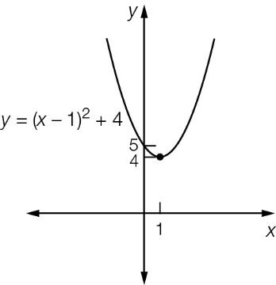

Question 19 3 marks [4.4]

Turning point is at (h, k) = (8, 3)

For x = 7: 

-2 = a + 3

a = 5

Short answer total marks: 54

Extended answer section

Question 20 6 marks [4.4]

(a)

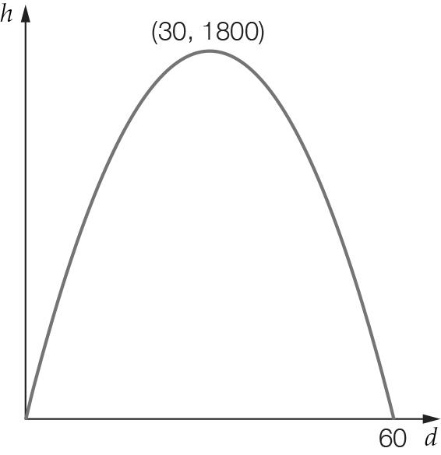

(b) Maximum height is at turning point (30, 1800), so maximum height is 1800 m.

(c) For y = 0:   
-2(d – 30)2 + 1800 = 0  
2(d – 30)2 – 1800 = 0  
(d – 30)2 – 900 = 0  
(d – 30 + 30)(d – 30 – 30) = 0  
d = 0 or 60  
Distance to target = 60 km

Question 21 6 marks [4.1]

(a) Area =   
= 

(b)   


(c) (i)   
 

(ii)  but 4x must be ≥ 4R

Therefore the shaded area can never be zero. A circle cut from a square will always leave waste.

Question 22 9 marks [4.2, 4.3, 4.4]

(a)

|  |  |  |  |  |  |  |  |
| --- | --- | --- | --- | --- | --- | --- | --- |
| x | 0 | 1 | 2 | 3 | 4 | 5 | 6 |
| y | 0 | 5 | 8 | 9 | 8 | 5 | 0 |

(b)

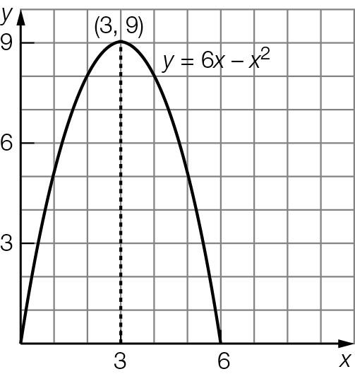

(c) (3, 9)

(d) x-intercepts are (0, 0) and (6, 0),   
y-intercept is (0, 0).

(e) 6x – x2 = 7 has solutions when x2 – 6x + 7 = 0  
x2 – 6x + 7 = 0   
x2 – 6x + 9 − 2 = 0   
(x − 3)2 –2 = 0  
x = 3 ± 1.41  
= 1.59 or 4.41

Check: 6 × 1.59 – 1.592 = 7.0, and 6 × 4.41 – 4.412 = 7.0

The ball was at a height of 7 m, 1.59 seconds and 4.41 seconds after the ball was thrown.

(f) There are two times, one when the ball was on the way up and the other when the ball was on the way down.

(g) The ball reaches a maximum height of 9 m. It does not reach the 10 m level so there are no times when this happens.

Question 23 4 marks [4.4]

The highest level is the k-value of the turning point. In turning point form:

h = -x(x – 8)

= -(x2 – 8x)

= -(x2 – 8x + 16) + 16

= -(x − 4)2 + 16

So the height reached is 16 m.

Extended answer total marks: 25

TOTAL test marks: 87